Object Oriented Development

# Generics Exercises

# What does this exercise cover?

# This exercise asks you to reinforce what you have learned by practicing with generic types.

# How long will the exercise take to complete?

# 1-2 hours

# What should you have already completed?

Java Generics Lecture

1. Write a generic class Pair that has two type parameters representing the type of the first and second element of the pair. Addgetters and setters for each.
2. Create a generic Catalog class for a library that will be able to hold books, borrowers, library staff, loans, etc, and will provide functionality to add items and find items by their ID. (Use a common interface for these.)

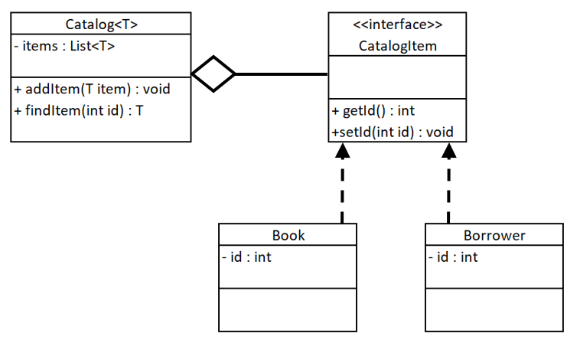

Make sure that every item that can be catalogued has an ID.

1. Make the IDs of your catalogued items generic.
2. Limit the ID types to numeric datatypes.